Hire Laravel Developer to Build Full-featured Enterprise Web Application.

Laravel: The Lightning-Smart Framework for PHP in 2020 and Beyond
(Laravel Popularity+ Business Benefits+ Benefits)
Laravel is free and an open-source PHP framework created by Taylor Otwell as an attempt to provide an advanced alternative to the CodeIgniter framework. There are certain features like authorization and authentication that are not included in CodeIgniter, so to fulfill your needs Laravel framework is created.
The best thing about Laravel is, it provides a modular packaging system, several ways for accessing relational databases and maintenance. Laravel framework is used globally, and 56,000+ developers appreciate the tremendous features of this platform. Today, Laravel is so popular because it provides the right tools to help you build web applications quickly, stable, and easy to maintain.
There are numbers frameworks available to build web application, but Laravel is an absolute choice for entrepreneurs. The reason is MVC pattern architecture easily lets you build strategic web applications in no time.
The popularity of Laravel Framework Compared to Other Similar Platforms

Find our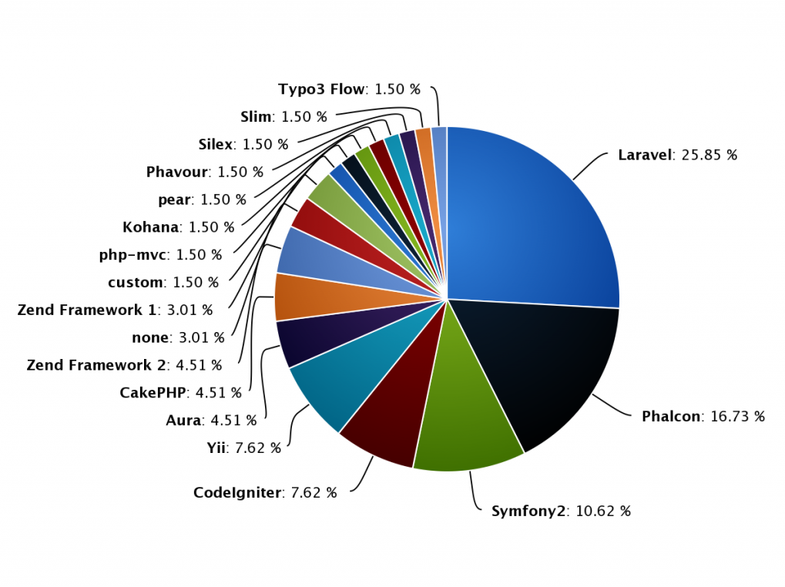
Find out why Laravel is The Perfect PHP Framework for Start-ups
You may be wondering about the major technical benefits of using Laravel framework to enhance your business, so here is the best out of all. Laravel enthusiasts are about to experience the best renaissance of the most popular framework for server-side scripting language of the web.
Powerful Authentication and Community
Laravel framework is created to build web applications faster and even in a better way. It is effortless for developers to implement the logic behind providing access to only authorized users. With authentication, Laravel has a great community to build your application as per your requirements and business needs. If you want to implement complex functionality, then Laravel community and ease of developer’s availability helps you get what you desired to have.
High Security
The number of cyberattacks is increasing day by day, so Laravel provides a safe environment when it comes to the web application by protecting it against serious issues such as SQL Injection and CSRF (Cross-Site Request Forgery). To prevent your application from cybercrime, Laravel uses a hazed password that will never save the plain text in the database.
“Be Risk-Free with Laravel”

Validation
Laravel provides a dominant feature of validation by default that uses a ValidationRequest trait with a convenient to control HTTP requests. It automatically checks errors in the session data and generates views if they are available.
Here are the validation rules available in Laravel: 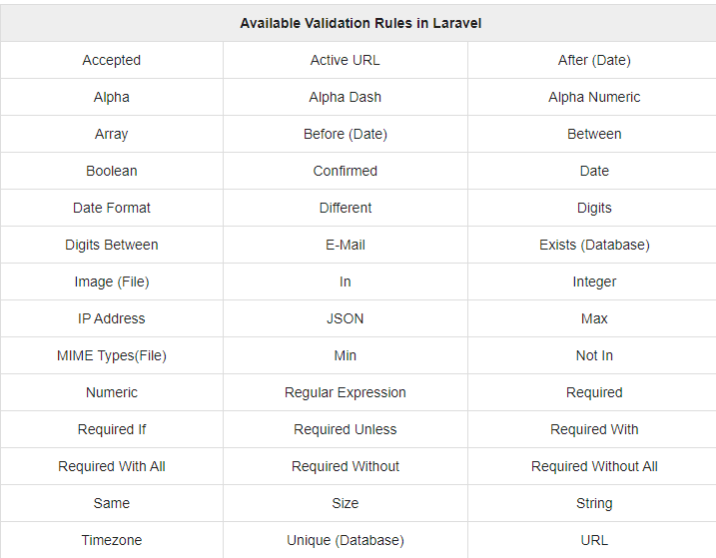

Image source: Tutorialpoint.com
Artisan Console
An artisan is a built-in tool in Laravel that allows you to perform complex tasks and to publish package assets. You can grab this functionality of Artisan by implementing new custom commands.
It is used to create database architecture and skeleton code with their migrations. Artisan allows you to execute repetitive and tedious tasks that developers avoid manually.
MVC Support
Laravel is purely an MVC-compliant framework that provides built-in support for the IOC (Inversion of Control) principle. Model View Controller helps to change and modify the template and codes easily.
It proves the performance of your application and maintains the overall process. So, Laravel is the most used and popular framework compared to other similar platforms.
Libraries and Modular
There are various Object-oriented libraries are added in Laravel framework whereas these pre-installed libraries are not included in other PHP frameworks. An authentication library contains features like reset passwords and monitoring active users. Laravel framework follows the PHP principles which allow the developers to build modular apps.
Separation of Code
This allows HTML Layout Designers to modify the webpage easily without any interaction with the developers. If every application has the separation of code in the early stage of development than fixing bugs can be made at a faster rate by the developer.
Laravel is capable of separating the code of the web application and this is a disadvantage of the other framework that can be overcome in the Laravel code separation feature.
Countries that Adopted Laravel for Business Growth
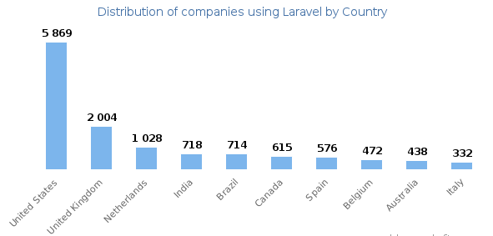

Key Reasons that Proves the Importance of Laravel Development in 2020
Laravel framework is capable of offering compelling methods when it comes to defining routes. It automatically loads all the routes that are implemented in the PHP file as app/HTTP/routes that make the process faster.
The in-built library of Laravel offers support for a distinction of influential log handlers. Through cloud-based services, it becomes easy to send emails without wasting any time using SparPost, Amazon SES, and Mandril.
Routing services that compensate for application maintenance and deployment are more natural. Laravel makes testing easier to encourage the behaviors of the users by using various types of outputs on the application. Laravel’s out-of-the-box introduces a new method Gate::inspect that makes easier to provide custom messages during the process of authorization requests if their request was declined.
Though various reasons prove the importance of Laravel development and the main reason is there are multiple ways for grabbing relational databases.
Top Tech Companies Using the Laravel Framework
#5. TourRadar
TourRadar was created by Travis and Shawn Pittman that specializes in the multi-day tour. It is an online travel agency having 40,000+ tours available from various tour operators globally.
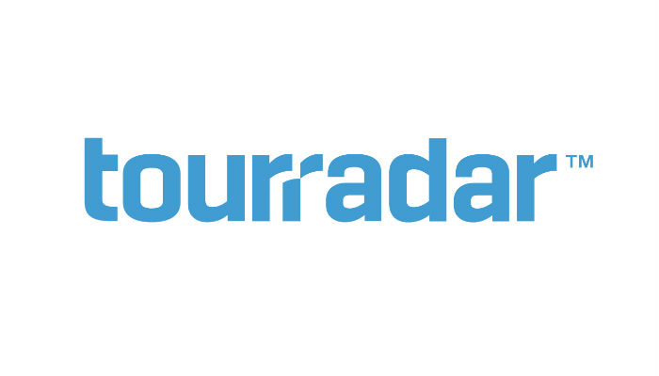
#4. Ratio
Ratio is a Fintech software company from the UK. They aim to help people in managing their finances. Ratio website ChooseWisely.co.uk helped 12 million users to choose the best financial product.
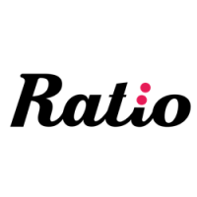
3. BBC
BBC is the oldest national broadcasting organization in the world, having many employees. They use PHP Laravel and Angular as well as works for various web applications for Content Production and TV.

2. Pfizer
Pfizer is the world’s largest pharmaceutical corporations ranked 57 in 2018 of the United States corporations by final revenue. If you check the Pfizer career page, they are hiring dedicated PHP developers with substantial experience in Laravel.
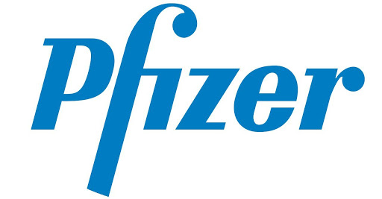
1.9GAG
9GAG is a popular online platform and social media website that allows users to share funny memes. The website receives more than 160 million visits per month! Sounds great, right? To handle modern technology and infrastructure, the engineering team uses PHP Laravel to their Stackshare.io.page.

The MVC Architecture
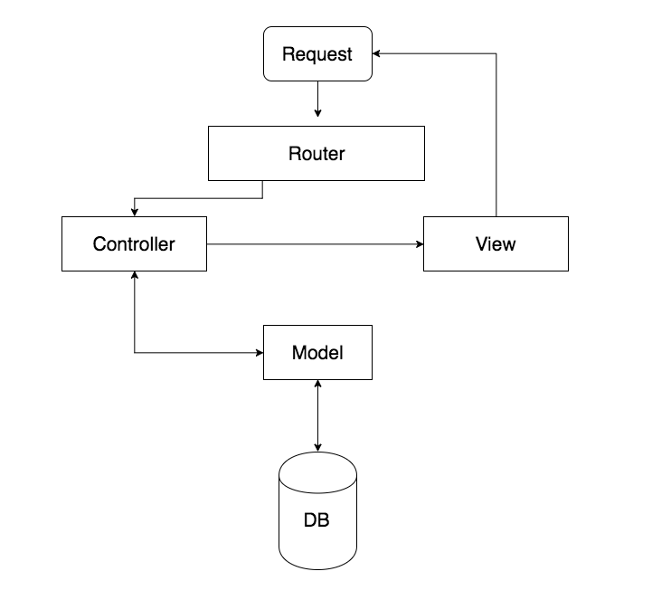
Still wondering? Why is Laravel so popular?
Relax. Watch this video clip and know why laravel is so popular.
https://youtu.be/flEhg1CFZLo
Looking for Laravel Application Development?
Laravel framework is the best tool-kit having object-oriented libraries pre-installed. Features like monitoring active users, encryption, and CSRF protection makes it more powerful than other platforms. Laravel developers at Bacancy Technology offers out-of-the-box benefits of Laravel framework that are suitable for various web application developments. If you are planning to build Laravel applications, then consider overall popularity and hire Laravel developers from us on an hourly, weekly, or monthly basis according to your business requirements.

